|  |
| --- |
| Covid BA.5 impact on student health and continued enrollment  Risk Assessment Report |
| Upward Bound University CIS650  RA1 |

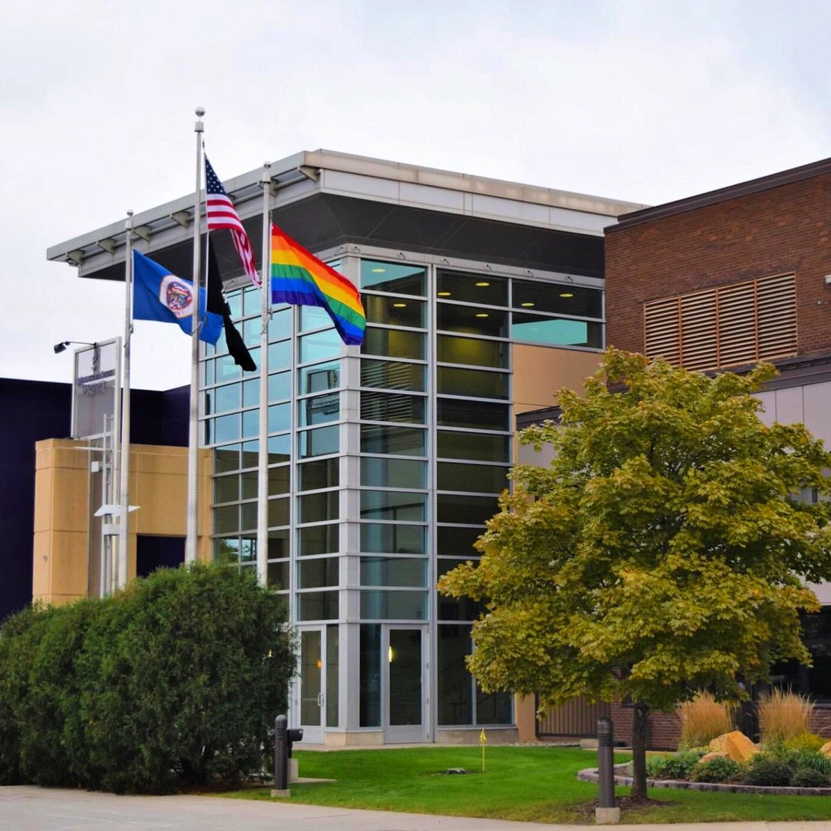

# 

**CIS 650 – RA1  
Utsav Khatiwada**

Contents

1

Overview: 3

Impact on Assets: 3

Impacts on university business(tuition): 4

Impacts on student enrollment: 4

Vulnerabilities: 4

Non-symptomatic Covid BA5: 4

CDC guidelines: 4

Carelessness from students and faculties: 5

Face to Face class: 5

Consequences: 5

Health Risk Assessment: 5

University Financial Risk Assessment 6

Risk assessment in future: 8

# Overview:

At Upward Bound University (10,000 undergrad students, 500 faculty), the administration has gotten increased reports of disruptions to “business as usual” stemming from the specific ability of Covid BA.5 to evade the community immunity that had been acquired through vaccinations and prior infections. Current policies at UBU have done away with any masking or vaccination requirements. Suspected cases of Covid are asked to follow the CDC’s current guidelines. Due to this, there have been reports of students being sick for several weeks, and thus missing major parts of their face-to-face courses. The administration is also noticing what appears to be the start of a trend where 2-3 times more students are dropping out mid-semester compared to prior years. This is a huge problem for universities and students, as not controlled by now there is a huge chance of transmission of Covid throughout the university. Moreover, it can lead to a lockdown of universities. This will directly affect the cash flow in the university as well as the health and education of the students.

# Impact on Assets:

The university contains different assets, either it is tangible or intangible including faculties, staff, students, buildings, and machinery. These assets are at high risk from Covid 19. As per the data, students are getting sick or dropping out of the university due to Covid. Staffs are not willing to come to university because of threats generated by Covid. Machinery and laboratory are not being used by students, but the cost to operate those Machines and laboratory are standing still. These things are creating a direct hamper on university finance. Following is the diagram representation of cost and utilization of machinery and laboratory before and after Covid 19.

Figure 2 Cost and Utilization of Machinery and Laboratory after Covid 19

Figure 1 Cost and Utilization of Machinery and Laboratory before Covid 19

# Impacts on university business(tuition):

As per the data of Upbound University, the annual budget of the university has increased significantly. The annual budget of the university is increasing by 1% each year due to Covid from 2019. This has a direct impact on the students as well because if the expenditure of the university is increasing then the university is compelled to increase tuition fees at the same ratio which will directly impact students. This increment can cause students to leave the university and go to college.

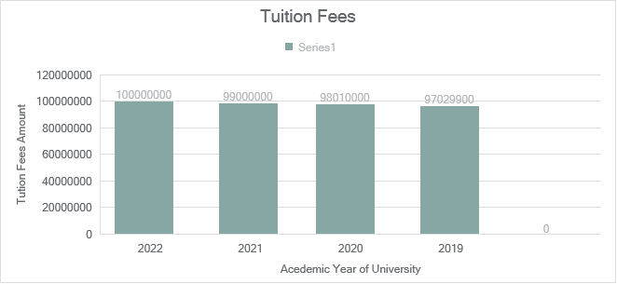

# Impacts on student enrollment:

One of the biggest threats to universities because of Covid BA5 is the reduction in student enrollment. If the Covid BA5 case keeps on growing it may cause the risk of isolation, anxiety, and boredom. Students will be less enthusiastic and serious about their studies. These things will lead students not to enroll in the classes. Even if there is enrollment there is a higher chance of students dropping out in the mid-semester.

# Vulnerabilities:

Non-symptomatic Covid BA5:  
 One of the vulnerabilities for the university could be Covid BA5 with no symptoms. If any student or faculty is diagnosed with non-symptomatic Covid BA5, there cannot be any track of that which can lead to transmission of Covid BA5.

CDC guidelines:  
 In the current scenario, CDC has not mandated vaccination and mask inside the university expand rapidly.

### Carelessness from students and faculties:

Self-care is very necessary to get protected from Covid BA5. If students and faculties are careless about Covid BA5, they can be diagnosed with it at some point. If this thing happens it will not only affect them whereas, but it will also affect another person who was in contact too.

### Face to Face class:

When students and faculties are in a face-to-face class then they are in close contact with each other. In case there is someone who has non-symptomatic Covid BA5 there is a high risk for other people in the class to get the disease transmitted.

# Consequences:

Due to the above vulnerability, student health can be hampered. Students will get diagnosed with Covid BA5. Moreover, students can get mentally distracted as well. Different mental diseases like anxiety, boredom, etc. can be caused due to no proper response to the vulnerabilities. Moreover, there is a likelihood of students leaving out in mid-semester which will create a financial loss for the university. The face-to-face class can increase the contact of students and faculties with each other which can increase the chance of Covid getting spread in the class. Ultimately, this will affect health and enrollment significantly. Moreover, the current CDC guidelines do not require masks and vaccination on the university premises. Due to this guideline spreading of the virus will be more serious and people can catch the virus immediately. Therefore, there should be a strict guideline that requires everybody in the university to adopt the mask and vaccination policy.

# Health Risk Assessment:

|  |  |  |
| --- | --- | --- |
| Threats | Risk Level | Control Measures |
| Decrease in Student Enrollment | High | Increase Scholarship and grant opportunities |
|  |  | Online education with required tools and technology |
| Students Dropping classes | Medium | Choice to change grading methods to P/NP |
| Student mental health getting hampered | Medium | Counseling sessions for mental health |
| Face to face classes | High | Move classes on online platform |
|  |  | Divide one class into 3 sessions with few students. |
|  |  | Mask and 6ft social distancing required for face-to-face class |
| Current CDC guidelines | Low | Add Universities specific guidelines to currently implemented guidelines |

# University Financial Risk Assessment

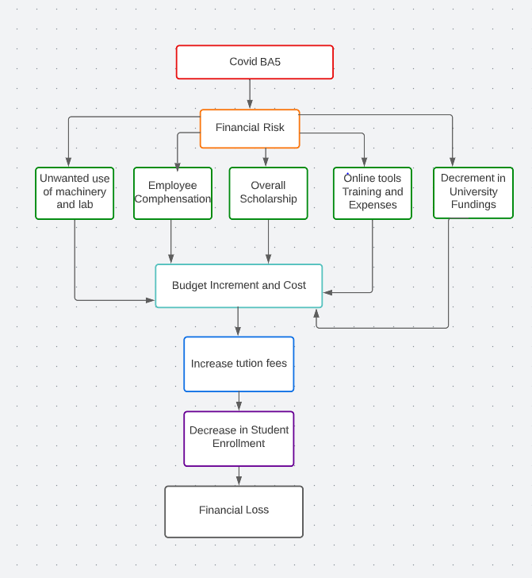Due to Covid BA 5. University finance is going in loss compared to prior years. It has affected different assets, faculties, and income source of university. Following is the financial risk for university due to Covid BA 5.

From the above table we get know the risk factors for university financial losses. These risk factors should be minimized to cut the cost of the university. To minimize these risk factors following are the control measures.

1. Cutting of unwanted lab and machinery.  
 if the students are not utilizing the physical lab and machinery in college, it is unwanted cost for the university, instead of running those physical lab and machines, online alternative tools can be provided to the students to cut off cost coming from those areas.

2. Employee compensation:

As per university data the compensation budget was increased up to 125 million dollars. To control this, the university can compensate 50% of the amount to the employees and provide guidelines to stay at home until the problem is solved.

3. Chosen Scholarships:

Every year scholarships are provided to the students which take a certain amount of budget from the university. To solve this university should apply a selection policy for the scholarship. For instance, scholarships should depend on students’ academic performance and athletic performance for athletes.

4. Guided Face to Face classes:

While completely switching to online classes can increase the cost of the online tools and training, which might affect the university budget. To control this some classes should be face-to-face but in a guided manner. For instance, if there is a class enrolled with 30 students, then that class should be divided into 3 sessions. Which can include 10 students at a time with proper guidelines of CDC. This might include masking mandatory, 6ft social distancing, and proper sanitization.

5. Collect extra funding from Alumni:

If the funding coming to the university is declining, one of the possible ways to increase funding is by asking for donations from the alumni. There is an alumni center in universities where the funds are collected from donations. This can somehow increase the income source for the university.

6. Loss Recovery application to Minnesota State:  
 Our university is funded by the state. So, if there is a loss in revenue, the university can write an application letter for loss recovery to the state, By doing this state can provide the university a fund according to the loss.

7. Free Covid testing camp:   
 A free Covid checkup camp should be organized so, that university can keep a track record of Covid cases and eliminate the upcoming threats.



Following Bar graph shows the revenue fluctuations from Covid BA5. The figure also analysis the increment and decrement in the revenue of business before Covid and current Covid situations. Moreover, it also explains and give statistical representation of controlling the loss revenue by applying control measures.

# Risk assessment in future:

After applying this mitigation in actions, with in every month there should be repeated risk assessments. According to the situation in future, other necessary actions and changes could be implemented.